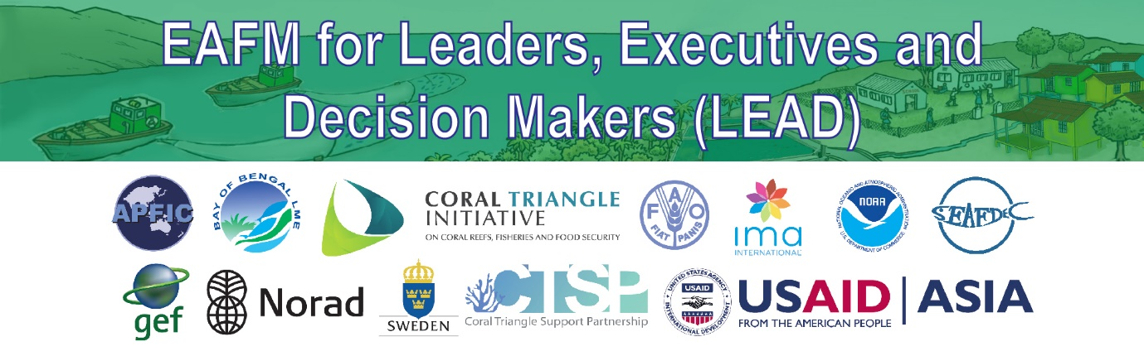
C2: Language
English meaning of key words in EAFM
PURPOSE
To provide a concise list of key words used in talking about EAFM and their meaning in English.
HOW TO USE THIS DOCUMENT
This list can be used as a glossary to look up the meaning of the key words in English.
Adaptive management: A systematic process for continually improving management policies and practices by learning from the outcomes of previously employed policies and practices. The basic steps of adaptive management are to implement actions, monitor their effectiveness; analyze, use and adapt; and then capture and share learning. Active adaptive management occurs where management options are used as a deliberate experiment for the purpose of learning (Millennium Ecosystem Assessment, 2006).
Benchmark: A standard against which something can be measured or judged. It can describe where you want to go (target), where you have come from (baseline) or where you do not want to be (limit).
Buy-in: The process that signifies the commitment of interested or affected parties to a decision (often called stakeholders) to 'buy into' the decision, that is, to agree to give it support, often by having been involved in its creation.
Co-management: Partnership arrangements between key stakeholders and government to share the responsibility and authority for the management of the fisheries and coastal resources, with various degrees of power sharing.
Ecosystem Approach (EA): A strategy for the integrated management of land, water and living resources that promotes conservation and sustainable use in an equitable way (CBD, 2000). Often used interchangeably with ecosystem-based management.
Ecosystem approach to fisheries management (EAFM): EAFM is a more holistic approach to management that represents a move away from fisheries management systems that focus only on the sustainable harvest of target species, towards systems and decision-making processes that balance ecological well-being with human and societal well-being, within improved governance frameworks i.e. it is a practical way to achieve sustainable development. It addresses the multiple needs and desires of societies, without jeopardizing the options for future generations to benefit from the full range of goods and services provided by marine ecosystems (Garcia et al., 2003; Food and Agriculture Organization 2003, 2011).
Ecosystem services: The benefits people obtain from ecosystems. These include provisioning services such as food and water; regulating services such as flood and disease control; cultural services, such as spiritual and cultural benefits; and supporting services, such as nutrient cycling or waste degradation, that maintain the conditions for life on Earth.
Fishery management unit (FMU): The area of the ecosystem and fisheries that is the focus for management under an ecosystem approach to fisheries management. The FMU can be a particular type of fishing, e.g. trawl fishery, and/or a particular resource fishery, e.g. shrimp fishery or a geographic area.
Governance: Effective institutions and arrangements for setting and implementing rules and regulations. It includes the planning and implementation mechanisms, processes and institutions through which citizens and governing groups (institutions and arrangements) voice their interests, mediate differences, exercise their legal rights and meet their obligations. Good governance includes (i) consensus, (ii) participation, (iii) accountability, (iv) transparency and (v) follows the rule of law and is (vi) responsive, (vii) equitable and inclusive and (viii) efficient and effective.
Human well-being: The state of the society in terms of health, education, food security, political voice and influence, living environment and economic security and safety.
Ecological well-being: The state of the ecosystem in terms of health, biodiversity, supportive structures and habitats and food webs.
Facilitator: A person who manages the interactions of other people to achieve an acceptable outcome for all.
Indicator: A variable, pointer, or index that measures the current condition of a selected component of the ecosystem. Indicators provide a link between objectives and action when they are compared to benchmarks.
Management goal: A broad statement of a desired outcome, often a specific theme (e.g. the environment or the fishing communities). Goals are usually not quantifiable and may not have established timeframes for achievement (see management objectives).
Management actions: Specific actions (sometimes called measures) applied to achieve the management objective, including gear regulations, areas and time closures (see MPA), and input and output controls on fishing effort, ecosystem manipulations or governance actions.
Management objective: What is intended to be achieved through management actions. An objective should be linked to indicator(s) against which progress can be measured. Positive or negative change resulting from the achievement of an objective is an outcome. (See definitions of vision and goal).
Outcome: The change in status, attitude or behaviour that results from a set of management activities. An outcome should be able to be tracked through measurement and/or observation over time.
Outputs: Tangible products produced by through the management process (e.g. EAFM Plan).
Precautionary approach (or principle): An underlying element of the broader framework of sustainable development. Where there are threats of serious or irreversible damage, lack of full scientific certainty shall not be used as a reason for postponing cost-effective measures to prevent environmental degradation (UNCED, 1992).
The United Nations Conference on Straddling Fish Stocks and Highly Migratory Fish Stocks (UN 1995) first articulated the principle for fisheries with the following definition:
“States shall be more cautious when information is uncertain, unreliable or inadequate. The absence of adequate scientific information shall not be used as a reason for postponing or failing to take conservation and management measures (UN, 1995).
The two ramifications of the precautionary approach are:
- Lack of data and information should not be used as an excuse for not taking action.
- Where there is uncertainty, management actions should be more risk averse.

Stakeholder: Any individual, group or organization who has an interest in (or a “stake”), or who can affect or is affected, positively or negatively, by a process or management decision.
Sustainability: Short hand for sustainable development that promotes development (improvement in human well-being) that meets the needs of the present without compromising the ability of future generations to meet their own needs. This requires a balance of human well-being (often in the short-term) with ecological well-being (often longer term degradation).
Trade-off: Achieving a balance between two desirable but incompatible features; a compromise.
Vision: A vision is the top-level aspiration of what the future (20-30 years) will look like if management is successful. (See goal and objective).

